# Services and programming

Effective Early Years Places offer integrated service delivery with wrap-around family support, where staff across different areas of the Early Years Place and any partner agencies operate together as a team. *How* services are delivered is just as important as *what* services are delivered.

Within the 'Services and programming' domain, you will be asked to assess and reflect on three key elements:

* 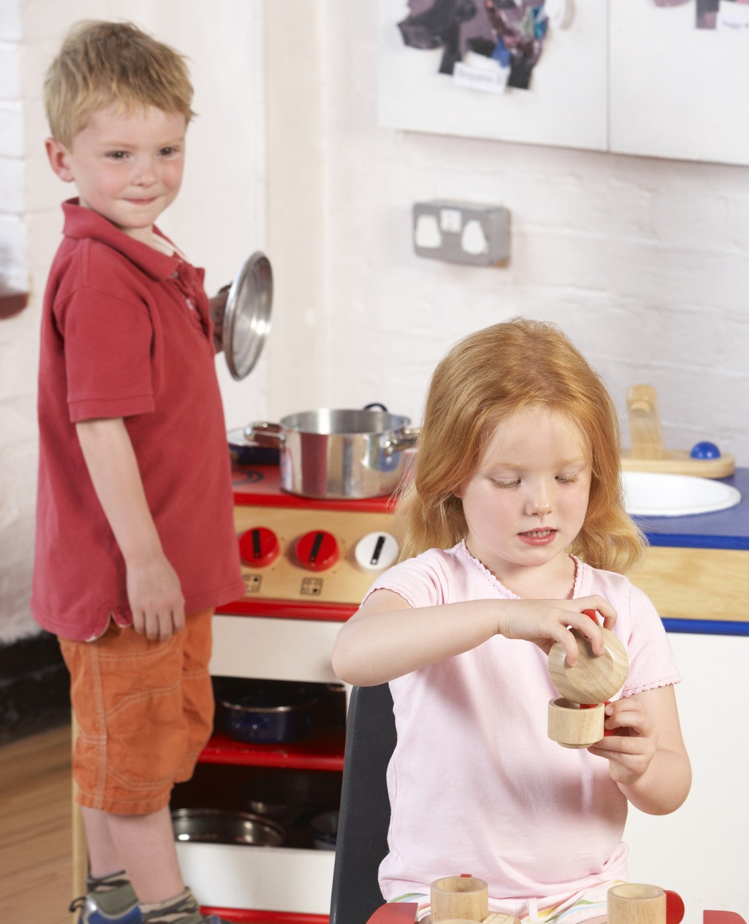Integration of services
* High quality early learning environments
* Other high-quality services/supports for children and families.

The following pages will help guide your assessment and reflection, as you consider how well the programs, services and support you offer are meeting the needs of the children and their families in your community.

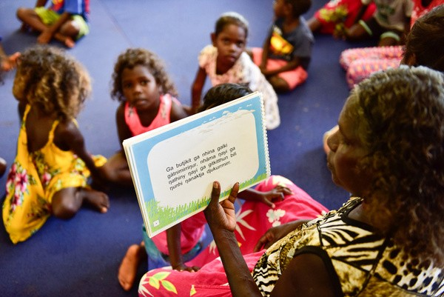

# Integration of services

## The levels of progression in the table below (emerging, evolving, established and excelling) are designed to help you reflect on what you are doing well, and where you might like to improve. Following this table is a checklist that will assist your reflection and self-assessment.

**DOMAIN: Services and programming**

|  |  |  |  |  |
| --- | --- | --- | --- | --- |
| **DOMAIN: Services and programming** | | | | |
| **ELEMENT:** | 1 – Emerging | 2 – Evolving | 3 – Established | 4 - Excelling |
| **Integration of services** | The Early Years Place has built or is building relationships with a small number of other relevant services.  Early Years Place staff induction covers principles of co-production and integrated service delivery. | The Early Years Place connects parents to services they need or are interested in, including schools, kindergartens and relevant support services.  Early Years Place staff meet regularly to discuss referral pathways, processes and issues.  Early Years Place staff and a range of service partners have contact with each other and know what they do. Some joint planning for families is taking place. | Referral pathways are smooth and understood by families.  Families can easily access ‘core’ service partners and specialist appointments (e.g. child and maternal health, allied health services, financial counselling) at our Early Years Place.  The Early Years Place provides extra assistance to families to access and attend services and activities, when needed. | Families receive seamless wrap-around support from Early Years Place staff, service partners and specialists.  There is a central/single intake and consent process for all services at our Early Years Place.  Referring practitioners have a strong connection with staff at our Early Years Place.  Early Years Place staff and service partners ask for help or advice when it is needed, offer each other regular feedback, and attend joint professional development activities. |

Continued over page...

|  |  |  |  |  |
| --- | --- | --- | --- | --- |
| **ELEMENT:** | 1 – Emerging | 2 – Evolving | 3 – Established | 4 - Excelling |
| **Integration of services** |  | Early Years Place staff have time to build relationships with other relevant stakeholders.  Active networking between Early Years Place staff and service partners is encouraged.  There is some sharing of data across services/ programs. | Early Years Place staff and service partners share a common language, may offer feedback to each other, and attend joint professional development activities.  Early Years Place staff and service partners are encouraged to contribute to joint meeting agendas. | Regular meetings between Early Years Place staff and service partners are facilitated. Early Years Place staff and service partners actively participate in meeting agenda setting and discussion.  Integration with service partners - including co-ordinated planning - enables the Early Years Place to be nimble and flexible with service/program offerings in response to local needs.  Early Years Place staff and service partner practitioners operate as a collective, cohesive team. |

## Consider the examples in the table below and assess whether these form part of your Early Years Place practice.

Established

Evolving

Emerging

Emerging

Evolving

Established

|  |  |  |  |  |
| --- | --- | --- | --- | --- |
|  | **Never** | **Sometimes** | **Always** | **N/A** |
| The Early Years Place has built or is building relationships with a small number of services. |  |  |  |  |
| Early Years Place staff induction covers principles of co-production by participants and integrated service delivery. |  |  |  |  |
| The Early Years Place connects parents to services that they have identified a need for or interest in, including schools and kindy. |  |  |  |  |
| Early Years Place staff meet regularly to discuss referral pathways, processes and issues. |  |  |  |  |
| Early Years Place staff and a range of service partners have contact with each other and know their different roles. Some joint planning for families is taking place across these partnerships. |  |  |  |  |
| Early Years Place staff have or make time to build relationships with other stakeholders. |  |  |  |  |
| Active networking between Early Years Place staff and service partners is supported and encouraged. |  |  |  |  |
| There is some sharing of data across services/programs. |  |  |  |  |
| Families understand the referral pathways and easily engage with them. |  |  |  |  |
| Families can easily access ‘core’ service partners and specialist appointments (e.g. child and maternal and allied health services, counselling) at the Early Years Place. |  |  |  |  |
| The Early Years Place provides extra help to support families to access and attend services and activities, when needed. |  |  |  |  |

Continued over page...

Excelling

Established

|  |  |  |  |  |
| --- | --- | --- | --- | --- |
|  | **Never** | **Sometimes** | **Always** | **N/A** |
| Early Years Place staff and service partners share and use a common language (cross disciplinary), may offer feedback to each other, and attend joint professional development activities. |  |  |  |  |
| Early Years Place staff and service partners are encouraged to contribute to joint meeting/planning agendas. |  |  |  |  |
| Families receive seamless wrap-around support from Early Years Place staff, service partners and specialists. |  |  |  |  |
| There is a central/single intake and consent process for all services offered at the Early Years Place. |  |  |  |  |
| Referring practitioners have a strong connection and professional relationships with staff at the Early Years Place. |  |  |  |  |
| Early Years Place staff and service partners ask for help or advice when it is needed, offer each other regular feedback, and attend joint professional development activities. |  |  |  |  |
| Regular meetings between Early Years Place staff and service partners are important and supported. Early Years Place staff and service partners actively participate in meeting agenda setting and discussion. |  |  |  |  |
| Integration with service partners - including co-ordinated planning - enables the Early Years Place to be nimble and flexible with service/program offerings in response to local needs. |  |  |  |  |
| Early Years Place staff and service partner practitioners operate as a collective and cohesive team. |  |  |  |  |

**Never**

## Are there other examples of **service integration** that have been important or made a difference to your Early Years Place that you would like to note

|  |  |
| --- | --- |
| **Response** |  |
| Click here to enter text. | |

Are there any challenges or barriers in relation to **integration of services** that you would like to note?

|  |  |
| --- | --- |
| **Response** |  |
| Click here to enter text. | | |

Is there anything you would like to do more of or differently in relation to integration of services, programs and support across your Early Years Place?

|  |  |
| --- | --- |
| **Response** |  |
| Click here to enter text. | |

Are there any challenges or barriers in relation to **integration of services** that you would like to note?

*Consider the following reflection questions:*

* What mechanisms do you have in place to share important information about families across different programs and services? Do you feel Early Years Place staff and partner agency staff share a common practice approach? If not, what might help to develop common ground?
* Do you have a strong sense or understanding of other relevant services in your community, and how you might work together to support families?
* Are your referral processes simple for families to follow and engage with?
* How effective is the feedback loop between your Early Years Place and partner services including specialists?
* **How does integration work in other Early Years Places? Can some of these ways of working be adopted in your Early Years Place**

|  |  |
| --- | --- |
| **Response** |  |
| Click here to enter text. | |

# High quality early learning environments

## The levels of progression in the table below (emerging, evolving, established and excelling) are designed to help you reflect on what you are doing well, and where you might like to improve. Following this table is a checklist that will assist your reflection and self-assessment.

**DOMAIN: Services and programming**

|  |  |  |  |  |
| --- | --- | --- | --- | --- |
| **DOMAIN: Services and programming** | | | | |
| **ELEMENT:** | 1 – Emerging | 2 – Evolving | 3 – Established | 4 - Excelling |
| **High quality early learning environments** | The Early Years Place provides space for families to spend time together, including playing and learning together.  Children’s artwork/ activities are displayed around the Early Years Place so that other families can see and learn from them. | The Early Years Place runs an early years learning program or facilitates playgroups.  Early Years Place staff sometimes meet with the local kindies/ schools to develop programs or activities. | The Early Years Place works with partner agencies to identify those children not accessing an early years learning service and works with parent/carers to encourage and support attendance.  Programs for parents/carers include discussing the importance of the home learning environment, and how Early Years Place staff model how to support children’s learning.  Staff collaborate with kindies, schools and other service partners (e.g. ECIS, NDIS) to support children and families to transition smoothly to kindy/school. | There has been consistent growth in the number of families from socially isolated and/or families living in vulnerable circumstances attending the Early Years Place early learning programs.  All children attending the Early Years Place, whether enrolled in early learning or not, have the opportunity to engage in rich, quality learning through the setting up of purposeful learning activities.  The Early Years Place supports the smooth transition to kindy and/or school with appropriate and relevant skills and knowledge. |

Continued over page...

|  |  |  |  |  |
| --- | --- | --- | --- | --- |
| **ELEMENT:** | 1 – Emerging | 2 – Evolving | 3 – Established | 4 - Excelling |
| **High quality early learning environments** |  |  | Programs continue over school holiday periods.  The Early Years Place has intentional and planned opportunities for children to learn through play. | Staff explicitly model to families how children learn through play.  Information and relevant data are shared between our Early Years Place and school, with consent from the family.  Early Years Place early learning program staff and primary/early years teachers participate in joint professional development, planning and reflection activities. |

## Consider the examples in the table below and assess whether these form part of your Early Years Place practice.

Emerging

Established

Evolving

|  |  |  |  |  |
| --- | --- | --- | --- | --- |
|  | **Never** | **Sometimes** | **Always** | **N/A** |
| The Early Years Place provides child friendly spaces for families to spend time together including playing and learning together. |  |  |  |  |
| Children’s artwork/ activities are displayed and conducted around the Early Years Place so that other families can see, talk about, interact with and learn from them. |  |  |  |  |
| The Early Years Place operates an early years learning program and/or facilitates targeted or universal playgroups. |  |  |  |  |
| The Early Years Place staff meet with the local kindies/schools to develop programs or activities. |  |  |  |  |
| The Early Years Place works with partner agencies to identify those children not accessing Kindy and engages with families to understand their needs, address any challenges and work with them to encourage participation. |  |  |  |  |
| Programs for parents/carers include discussion about the importance of the home learning environment and children’s development and the Early Years Place staff model how to support children’s learning. |  |  |  |  |
| Staff collaborate with kindies, schools and other service partners (e.g. ECIS, NDIS) to support children and their families to transition smoothly to kindy/school. |  |  |  |  |
| Programs continue to operate over school holiday periods to provide continuity of interactions. |  |  |  |  |
| The Early Years Place has intentional, planned opportunities for children to learn through play. |  |  |  |  |

Continued over page...

Excelling

|  |  |  |  |  |
| --- | --- | --- | --- | --- |
|  | **Never** | **Sometimes** | **Always** | **N/A** |
| There has been consistent growth in the number of families from vulnerable communities attending the Early Years Place early learning programs |  |  |  |  |
| All children attending the Early Years Place, whether enrolled in Kindy or not, have the opportunity to engage in rich, quality learning through the setting up of purposeful learning activities |  |  |  |  |
| The Early Years Place supports the smooth transition to kindy and/or school with appropriate and relevant skills and knowledge. |  |  |  |  |
| Early Years Place staff explicitly model to families how children learn through play. |  |  |  |  |
| Information and relevant data are shared between our Early Years Place and school or other relevant partners, with consent from the family. |  |  |  |  |
| Early Years Place early learning program staff and early childhood teachers from partner organisations including schools and kindies participate in joint professional development, planning and reflection activities, where appropriate. |  |  |  |  |

**N/**

Are there other examples of **quality early learning environments** that have been important or made a difference to your Early Years Place that you would like to note?

|  |  |
| --- | --- |
| **Response** |  |
| Click here to enter text. | |

Are there any challenges or barriers in relation to **quality early learning environments** that you would like to note?

|  |  |
| --- | --- |
| **Response** |  |
| Click here to enter text. | |

Is there anything you would like to do more of or differently in relation to the **quality of your early learning environments**?

*Consider the following reflection questions:*

* How do you assess the quality of the early learning programs you provide?
* How might you model quality early learning at your Early Years Place in a way that encourages parents to improve the home learning environment?
* Does the set-up of your Early Years Place encourage children to play at any time (not just when sessions are scheduled)?
* What cultural or other factors might you need to consider when talking about or modelling early learning?
* Do your early learning services use the Early Years Learning framework or a practice framework?
* **What have other Early Years Places done to improve the quality of their early learning environments that might also work for you?**

|  |  |
| --- | --- |
| **Response** |  |
| Click here to enter text. | |

# Other high-quality services/supports

## The levels of progression in the table below (emerging, evolving, established and excelling) are designed to help you reflect on what you are doing well, and where you might like to improve. Following this table is a checklist that will assist your reflection and self-assessment.

**DOMAIN: Services and programming**

|  |  |  |  |  |
| --- | --- | --- | --- | --- |
| **DOMAIN: Services and programming** | | | | |
| **ELEMENT:** | 1 – Emerging | 2 – Evolving | 3 – Established | 4 - Excelling |
| **Other high-quality services and supports for children and families** | The Early Years Place offers informal developmental, social and emotional support to children and families.  The Early Years Place provides space for families to spend time together including playing and learning together. | The Early Years Place supports families to access additional child health and developmental services (e.g. mental health, speech pathology, occupational therapy, etc).  Early Years Place staff connect families to additional supports and services that promote families’ developmental, social and emotional wellbeing, including domestic violence services. | The Early Years Place or service partners provide (or facilitate referrals to) high quality speech pathology services.  The Early Years Place or service partners provide (or facilitate referrals to) high quality occupational therapy services.  The Early Years Place or service partners provide high quality mental health services.  The Early Years Place or service partners deliver programs to improve children’s problem-solving skills and ability to socialise with/relate to others. | The Early Years Place identifies any learning difficulties or developmental delays early and refers families to specialist support.  The Early Years Place provides one-on-one child behaviour/education support for families where a group program is not appropriate.  The Early Years Place uses an explicit practice framework for nurturing parents’ personal growth, leadership and learning.  The Early Years Place coordinates programs for under-represented groups, such as dads and teenage/young parents. |

Continued over page...

|  |  |  |  |  |
| --- | --- | --- | --- | --- |
| **ELEMENT:** | 1 – Emerging | 2 – Evolving | 3 – Established | 4 - Excelling |
| **Other high-quality services and supports for children and families** | Parents join in social and learning activities, with some support from Early Years Place staff. | The Early Years Place partners with services that can support families to access donated or second-hand goods (furniture, feeding equipment, etc).  The Early Years Place provides programs that allow parents to socialise with other parents. | The Early Years Place, service partners or other linked service agencies provide high quality antenatal support to expectant parents.  The Early Years Place or service partners provide high quality maternal and child health support to families.  The Early Years Place staff can respond quickly to urgent family needs, such as domestic violence.  The Early Years Place has processes and/or tools in place to screen/monitor families’ developmental, social and emotional support needs.  The Early Years Place provides assistance/information to caregivers on sleep, nutrition and other child developmental needs.  The Early Years Place helps link caregivers to financial supports (e.g. Centrelink) and/or  Early Years Place or service partners provide financial counselling support. | Health professionals (maternal and child health nurses, speech pathologists, etc) attend playgroups or other programs for caregivers to provide ‘informal’ support.  The Early Years Place or service partners provide wrap-around mental health support for caregivers.  The Early Years Place provides one-on-one parenting support for families where a group program is not appropriate.  The Early Years Place includes evidence-based information on child development across a range of parenting programs/services.  Referral pathways are clear and supportive and warm handover provided. |

Consider the examples in the table below and assess whether these form part of your Early Years Place practice.

Established

Evolving

Emerging

|  |  |  |  |  |
| --- | --- | --- | --- | --- |
|  | **Never** | **Sometimes** | **Always** | **N/A** |
| The Early Years Place offers informal developmental, social and emotional support to children and families. |  |  |  |  |
| The Early Years Place provides child friendly spaces for families to spend time together, including playing and learning together. |  |  |  |  |
| Parents and carers join in and participate in social and learning activities, with some support from Early Years Place staff. |  |  |  |  |
| The Early Years Place supports families to access additional child health and developmental services (e.g. mental health, speech pathology, occupational therapy, etc.). |  |  |  |  |
| Early Years Place staff connect families to additional supports and services that promote families’ developmental, social and emotional wellbeing, including domestic violence services. |  |  |  |  |
| The Early Years Place partners with services that can assist families to access donated or second-hand goods (furniture, feeding equipment, etc.), as needed. |  |  |  |  |
| The Early Years Place provides programs that allow parents and carers to socialise with others attending the centre. |  |  |  |  |
| The Early Years Place or service partners provide (or facilitate referrals to) high quality speech pathology services. |  |  |  |  |
| The Early Years Place or service partners provide (or facilitate referrals to) high quality occupational therapy services. |  |  |  |  |
| The Early Years Place or service partners provide (or facilitate referrals to) high quality mental health services |  |  |  |  |
| The Early Years Place or service partners deliver programs to improve children’s problem- solving skills and ability to socialise with/relate to others. |  |  |  |  |
| The Early Years Place, service partners or other linked service agencies provide high quality antenatal support to expectant parents. |  |  |  |  |
| The Early Years Place or service partners provide high quality maternal and child health support to families. |  |  |  |  |
| The Early Years Place staff can respond quickly to urgent family needs, such as domestic violence. |  |  |  |  |
| The Early Years Place has processes and/or tools in place to screen/monitor families’ developmental, social and emotional support needs. |  |  |  |  |

Continued over page….

|  |  |  |  |  |
| --- | --- | --- | --- | --- |
| The Early Years Place provides one-on-one child behaviour/education support for families where a group program is not appropriate. |  |  |  |  |
| The Early Years Place uses an explicit practice framework for nurturing parents’ personal growth, leadership and learning. |  |  |  |  |
| The Early Years Place coordinates specific programs for under-represented groups, including dads and teenage/young parents. |  |  |  |  |
| The Early Years Place provides one-on-one parenting program support for families where a group program is not appropriate. |  |  |  |  |
| The Early Years Place includes evidence-based information on child development across a range of parenting programs/services. |  |  |  |  |
| Health professionals (maternal and child health nurses, speech pathologists, etc.) attend playgroups or other programs for caregivers to provide ‘informal’ support. Early Years Place or service partners provide wrap-around mental health support for caregivers. |  |  |  |  |
| Referral pathways are clear and supportive handover is provided. |  |  |  |  |

**Never**

Excelling

Excelling

Excelling

**N**

Are there other examples of **high-quality services and supports** that you would like to note as important for your Early Years Place?

|  |  |
| --- | --- |
| **Response** |  |
| Click here to enter text. | |

Are there any challenges or barriers in relation to **high quality services and supports** that you would like to note?

|  |  |
| --- | --- |
| **Response** |  |
| Click here to enter text. | |

Is there anything you would like to do more of or differently in relation to the **quality of your services and support** for children and families?

*Consider the following reflection questions:*

* In what way are you valuing and enabling caring, responsive adult-child relationships – not just activities and intellectual learning?
* How could you create interactions or environments that give families the space to make positive decisions/positive change? Are there ways you can add value to physical spaces so they encourage play and exploration for children?
* How do you notice and celebrate adults who grow warm and responsive relationships with children?
* How might you impart information about early childhood development to parents, without using information sheets? Are you able to identify and support children exhibiting social-emotional difficulties?
* Are your programs and services underpinned by a practice framework or logic model? If not, can one be developed?
* Are you able to deliver parenting program content in different formats, if families are not comfortable attending group sessions?
* Have you considered training service users to provide peer-led programs and services?
* **What programs, services or support are other Early Years Places providing that might help families in your community?**

|  |  |
| --- | --- |
| **Response** |  |
| Click here to enter text. | |

Self-assessment and reflection complete

Well done! You have completed your self-assessment and reflection of the **Services and programming** domain. We hope this has helped to pinpoint areas of focus for future planning and improvement.

Remember to save a copy of your responses for your records.

