# Staffing

Effective Early Years Places employ friendly staff who practice with deep empathy and use approaches that empower families and foster independence.

Within the 'Staffing' domain, you will be asked to assess and reflect on three key elements:

* Professional skills and qualifications
* Practice values and approach
* Professional development

The following pages will help guide your assessment and reflection, as you consider how well your Early Years Place staffing meets the needs of children and families in your community.

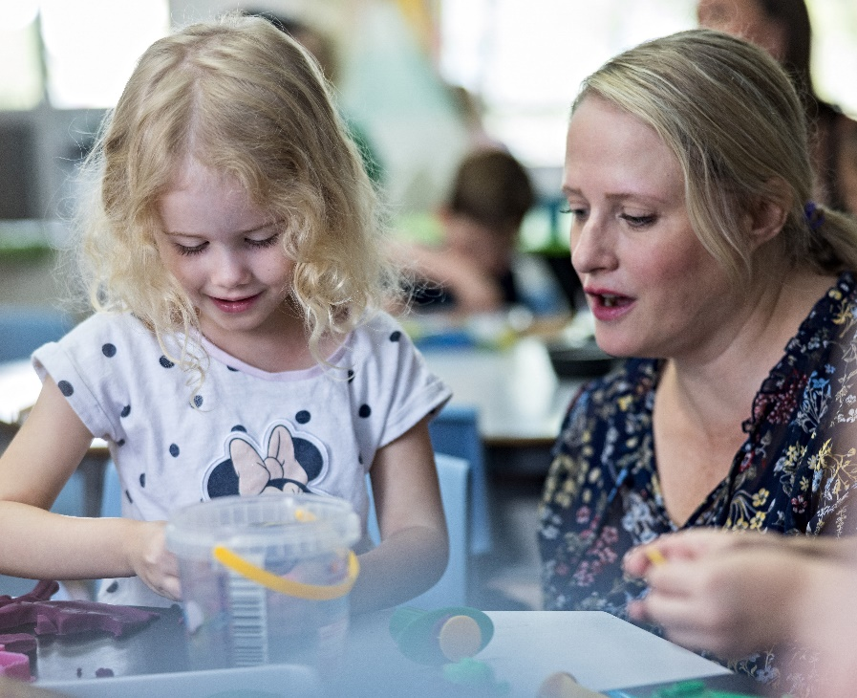

# Professional skills and qualifications

## The levels of progression in the table below (emerging, evolving, established and excelling) are designed to help you reflect on what you are doing well, and where you might like to improve. Following this table is a checklist that will assist your reflection and self-assessment.

**DOMAIN: Staffing**

|  |  |  |  |  |
| --- | --- | --- | --- | --- |
| **DOMAIN: Staffing** | | | | |
| **ELEMENT:** | 1 – Emerging | 2 – Evolving | 3 – Established | 4 - Excelling |
| **Professional skills and qualifications** | Early Years Place staff have a basic understanding of child development.  Early Years Place staff have a basic understanding of trauma and its effects on families. | Some Early Years Place staff have knowledge and skills in evidence-based approaches to responding to trauma.  Early Years Place staff offer a range of different skills and expertise.  Early Years Place staff have the right expertise to ensure a culturally appropriate environment. | Early Years Place staff and service partners confidently adopt an evidence-based approach to addressing trauma experienced by parents and children.  Bilingual staff are available to support local families, as appropriate.  Staff have a strong understanding of early childhood development and learning and can identify developmental problems. | Early Years Place staff and service partners apply an evidence-based, trauma-informed approach when addressing trauma experienced by parents/carers and children.  Early Years Place uses a ‘key worker’ (or similar) model for families with complex, multiple-service needs.  Staff have the skills to adapt programs/services for Aboriginal and Torres Strait Islander children and children from culturally and linguistically diverse backgrounds and children with disability. |

Consider the examples in the table below and assess whether these form part of your Early Years Place practice.

Excelling

Evolving

Established

Emerging

|  | **Never** | **Sometimes** | **Always** | **N/A** |
| --- | --- | --- | --- | --- |
| Early Years Place staff have a basic understanding of child development and learning. |  |  |  |  |
| Early Years Place staff have a basic understanding of trauma and its effects on families. |  |  |  |  |
| Some Early Years Place staff have knowledge and skills in evidence-based approaches to responding to trauma. |  |  |  |  |
| Early Years Place staff have the right expertise to ensure a culturally appropriate environment. |  |  |  |  |
| Early Years Place staff offer a range of different skills and expertise in service delivery, planning and engagement. |  |  |  |  |
| Bilingual staff are available to support local families, where appropriate. |  |  |  |  |
| Early Years Place staff and service partners confidently adopt an evidence-based approach to addressing trauma experienced by parents and children. |  |  |  |  |
| Staff have a strong understanding of early childhood development and learning, and can identify developmental issues. |  |  |  |  |
| Early Years Place staff and service partners apply an evidence-based, trauma- informed approach when addressing trauma experienced by parents/carers and children. |  |  |  |  |
| Early Years Place uses a ‘key worker’ (or similar) model for families with complex, multiple-service needs. |  |  |  |  |
| Staff have the skills to adapt programs/services for children from culturally diverse backgrounds and children with disability. |  |  |  |  |

**Never**

**N**

Are there other examples of staff **professional skills and qualifications** that you would like to note as important for your Early Years Place?

|  |  |
| --- | --- |
| **Response** |  |
| Click here to enter text. | |

Are there any challenges or barriers in relation to staff **professional skills and qualifications** that you would like to note?

|  |  |
| --- | --- |
| **Response** |  |
| Click here to enter text. | |

Is there anything you would like to do more of or differently in relation to the **professional skills and qualifications** of your staff?

*Consider the following reflection questions:*

* How well do you think the skills and qualifications of staff match the needs of local families?
* How might you assist families to feel comfortable providing feedback on their interactions with staff?
* Do staff have skills and experiences working with vulnerable families? What further support can be provided?
* Are the numbers of staff skilled in trauma-informed practice sufficient to meet the needs of your community?
* How might you support staff to develop skills in ‘coaching’ rather than ‘teaching’ or ‘advising’ (which may differ from their previous professional roles)?
* **Have you spoken to other Early Years Places about the skills and qualifications of their staff and how they might be similar or different to yours?**

|  |  |
| --- | --- |
| **Response** |  |
| Click here to enter text. | |

# Practice approach and values

## The levels of progression in the table below (emerging, evolving, established and excelling) are designed to help you reflect on what you are doing well, and where you might like to improve. Following this table is a checklist that will assist your reflection and self-assessment.

**DOMAIN: Staffing**

|  |  |  |  |  |
| --- | --- | --- | --- | --- |
| **DOMAIN: Staffing** | | | | |
| **ELEMENT:** | 1 – Emerging | 2 – Evolving | 3 – Established | 4 - Excelling |
| **Practice approach and values** | Early Years Place staff focus on developing relationships with the families and communities they are working with. | Early Years Place staff build respectful and trusting relationships with families.  Early Years Place staff understand and support what is working well for parents/carers and their child/ren.  Staff deeply understand the cultural context of the families they are working with. | Early Years Place staff and service partners make time to chat with families outside of meetings or appointments and make efforts to remember families’ stories and strengths.  Early Years Place staff are trained in and supported to apply evidence-based principles of family-centred practice.  Early Years Place staff build on the strengths of families and understand their needs and priorities. | Early Years Place staff regularly reflect on their cultural values and identify and act on power imbalances with families.  Early Years Place staff are accessible and professional, agile and responsive.  Families, service partners and Early Years Place staff recognise, build on and celebrate family successes.  Family-centred practice and capacity-building practices are made explicit in a practice framework. |

Continued over page...

|  |  |  |  |  |
| --- | --- | --- | --- | --- |
| **ELEMENT:** | 1 – Emerging | 2 – Evolving | 3 – Established | 4 - Excelling |
| **Practice approach and values** |  |  | Early Years Place staff recognise that parents/carers have significant untapped potential and a strong sense of agency.  Early Years Place staff consciously build the capability of the parents/carers they work with. | Early Years Place staff seek to create a ‘multiplier effect’; showing families how small actions and successes in one part of their lives can create a reinforcing cycle of positive change in other areas of their lives.  Early Years Place staff employ ‘biodegradable support’: as families’ skills and confidence grow, staff provide less structured support to foster independence.  Early Years Place staff acknowledge that people are experts in their own lives. |

## Consider the examples in the table below and assess whether these form part of your Early Years Place practice.

Excelling

Established

Evolving

Emerging

|  | **Never** | **Sometimes** | **Always** | **N/A** |
| --- | --- | --- | --- | --- |
| Early Years Place staff focus on developing relationships with the families and communities they are working with. |  |  |  |  |
| Early Years Place staff build respectful and trusting relationships with families. |  |  |  |  |
| Early Years Place staff support what is working well for families and their child |  |  |  |  |
| Staff deeply understand the cultural context of the families they are working with. |  |  |  |  |
| Early Years Place staff and service partners make time to chat with families outside of meetings or appointments and make efforts to remember families’ stories and strengths. |  |  |  |  |
| Early Years Place staff are trained in and supported to apply evidence-based principles of family-centred practice. |  |  |  |  |
| Early Years Place staff build on the strengths of families and understand their needs and priorities. |  |  |  |  |
| Early Years Place staff recognise that parents have significant untapped potential and a strong sense of agency. |  |  |  |  |
| Early Years Place staff consciously build the capability of the parents they work with. |  |  |  |  |
| Early Years Place staff are accessible and professional, agile and responsive. |  |  |  |  |
| Families, service partners and Early Years Place staff recognise, build on and celebrate family successes. |  |  |  |  |
| Family-centred practice and capacity-building practices are made explicit in a practice framework. |  |  |  |  |
| Early Years Place staff seek to create a ‘multiplier effect’; showing families how small actions and successes in one part of their lives can create a reinforcing cycle of positive change in other areas of their lives. |  |  |  |  |
| Early Years Place staff employ ‘biodegradable support’: as families’ skills and confidence grow, staff provide less structured support to foster independence. |  |  |  |  |
| Early Years Place staff acknowledge that people are experts in their own lives. |  |  |  |  |
| Early Years Place staff regularly reflect on their cultural values and identify and act on power imbalances with families. |  |  |  |  |

Are there other examples of staff **practice approaches and values** that you would like to note as important for your Early Years Place?

|  |  |
| --- | --- |
| **Response** |  |
| Click here to enter text. | |

Are there any challenges or barriers in relation to staff **practice approaches and values** that you would like to note?

|  |  |
| --- | --- |
| **Response** |  |
| Click here to enter text. | |

Is there anything you would like to do more of or differently in relation to the **practice approach and values** of your staff?

*Consider the following reflection questions:*

* Do staff approach their interactions with families as a partnership, rather than an expert-client relationship?
* How well do you think staff acknowledge the assets and resources people have, and start with a strengths-based approach?
* Do you give your staff time to model and encourage positive relationships with children?
* How well do staff apply the principles of family-centred practice?
* Does your staffing model reflect the local cultural demographics?
* **Have you spoken to other Early Years Places about the practice approach and values of their staff and how they might be similar or different to yours?**

|  |  |
| --- | --- |
| **Response** |  |
| Click here to enter text. | |

# Professional development

The levels of progression in the table below (emerging, evolving, established and excelling) are designed to help you reflect on what you are doing well, and where you might like to improve. Following this table is a checklist that will assist your reflection and self-assessment.

|  |  |  |  |  |
| --- | --- | --- | --- | --- |
| **ELEMENT:** | **DOMAIN: Staffing** | | | |
| **Professional development** | 1 – Emerging | 2 – Evolving | 3 – Established | 4 - Excelling |
|  | Opportunities for reflective practice are provided for Early Years Place staff.  Some Early Years Place staff have undertaken cultural training and family-centred practice training.  Centre leaders participate in leadership development. | Processes and tools for reflective practice are established.  New Early Years Place staff have the opportunity to meet peers (or other Early Years Place centre staff) virtually.  Some opportunities for staff professional development are provided. | Early Years Place staff and service partners regularly undertake reflective practice (individually, as a team, and with other Early Years Places).  All Early Years Place staff participate in quality and holistic professional supervision, which monitors and supports staff wellbeing.  New Early Years Place staff can spend time in another centre to develop skills, knowledge and new ways of working. | A culture of reflection has been established at the Early Years Place – there are opportunities for Early Years Place staff, service partners and families to regularly reflect on interactions, activities, ways of working and learnings.  Joint Early Years Place staff or service partner professional learning opportunities are planned, supported, undertaken and involve families, as appropriate.  All Early Years Place staff demonstrate growth in learning and improved practices, enabled through continuous professional learning activities and supervision. |

Continued over page...

|  |  |  |  |  |
| --- | --- | --- | --- | --- |
| **ELEMENT:** | 1 – Emerging | 2 – Evolving | 3 – Established | 4 - Excelling |
| **Professional development** |  | Early Years Place staff receive induction into co-design, family-centred practice and integrated service delivery. | Early Years Place staff receive training in how to have difficult conversations (including with parents/carers).  All staff receive cultural safety/awareness training.  All Early Years Place staff participate in induction and continuous professional learning, informed by professional development plans (e.g. trauma-informed practice, emotional regulation, leadership). | The Early Years Place culture encourages all staff and practitioners to seek help to promote, maintain and manage staff wellbeing. Staff regularly give and receive support to one another.  New Early Years Place staff can spend time in another centre; existing Early Years Place staff can participate in peer ‘swaps’ with other Early Years Places, where appropriate and feasible.  Early Years Place staff are able to debrief with a supervisor as required. |

Consider the examples in the table below and assess whether these form part of your Early Years Place practice.

Established

Evolving

Emerging

|  | **Never** | **Sometimes** | **Always** | **N/A** |
| --- | --- | --- | --- | --- |
| Opportunities for reflective practice are provided for Early Years Place staff. |  |  |  |  |
| Some Early Years Place staff have undertaken cultural training and family- centred practice training. |  |  |  |  |
| Centre leaders participate in leadership development. |  |  |  |  |
| Processes and tools for reflective practice are established. |  |  |  |  |
| Some opportunities for staff professional development are provided. |  |  |  |  |
| New Early Years Place staff have the opportunity to meet their peers (or other Early Years Place centre staff) virtually. |  |  |  |  |
| Early Years Place staff receive induction into co-production, family-centred practice and integrated service delivery. |  |  |  |  |
| Early Years Place staff and service partners regularly undertake reflective practice (individually, as a team, with other Early Years Places). |  |  |  |  |
| All Early Years Place staff participate in quality and holistic professional supervision, which monitors and supports staff wellbeing. |  |  |  |  |
| New Early Years Place staff can spend time in another centre to gain knowledge, skills and consider other ways of working. |  |  |  |  |
| All Early Years Place staff participate in induction and continuous professional learning, informed by professional development plans (e.g. trauma-informed practice, emotional regulation, leadership). |  |  |  |  |
| Early Years Place staff receive training in how to have difficult conversations (including with caregivers). |  |  |  |  |
| All staff receive cultural safety/awareness training. |  |  |  |  |
| There are opportunities for Early Years Place staff, service partners and families to regularly reflect on interactions, activities, ways of working and learnings. A culture of reflection has been established at the Early Years Place. |  |  |  |  |

Continued over page...

Excelling

|  | **Never** | **Sometimes** | **Always** | **N/A** |
| --- | --- | --- | --- | --- |
| Joint Early Years Place staff/service partner professional learning opportunities are planned, supported, undertaken and involve families, as appropriate. |  |  |  |  |
| All Early Years Place staff demonstrate growth in learning and improved practices, enabled through continuous professional learning activities and supervision. |  |  |  |  |
| Early Years Place culture encourages all staff and practitioners to seek help to promote, maintain and manage staff wellbeing. Staff regularly give and receive support to one another. |  |  |  |  |
| New Early Years Place staff can spend time in another centre; existing Early Years Place staff can participate in peer ‘swaps’ with other Early Years Places, where appropriate. |  |  |  |  |
| Early Years Place staff are able to debrief with a supervisor as required. |  |  |  |  |

## Are there other examples of staff **professional development** that you would like to note as important for your Early Years Place?

|  |  |
| --- | --- |
| **Response** |  |
| Click here to enter text. | |

Are there any challenges or barriers in relation to staff **professional development** that you would like to note?

|  |  |
| --- | --- |
| **Response** |  |
| Click here to enter text. | |

Is there anything you would like to do more of or differently in relation to staff **professional development**?

*Consider the following reflection questions:*

* What opportunities exist for the Early Years Place team to access additional learning?
* What supports exist for the Early Years Place workforce, including staff wellbeing support?
* What other resources could you access to support professional development that might not require a budget?
* **Are there ways you can share professional development opportunities or learnings with other Early Years Places?**

|  |  |
| --- | --- |
| **Response** |  |
| Click here to enter text. | |

Self-assessment and reflection complete

Well done! You have completed your self-assessment and reflection of the **Staffing** domain. We hope this has helped to pinpoint areas of focus for future planning and improvement.

Remember to save a copy of your responses for your records.

