Transcript for recorded webinar - Introduction to the NDIS for ECEC services–January 2020
Slide No | Slide Image | Slide Title | Transcript
1 | 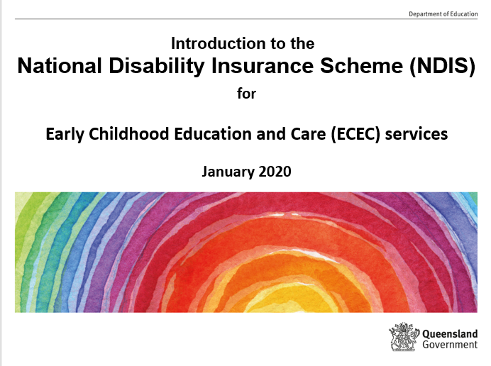 | Introduction to the  National Disability Insurance Scheme for  Early Childhood Education and Care services | - Welcome to the webinar Introduction to the National Disability Insurance Scheme (known as the NDIS) for staff working in Early Childhood Education and Care services across Queensland.  - My name is Carol Hughes and I work in the Early Childhood and Community Engagement division of the Department of Education.
2 | 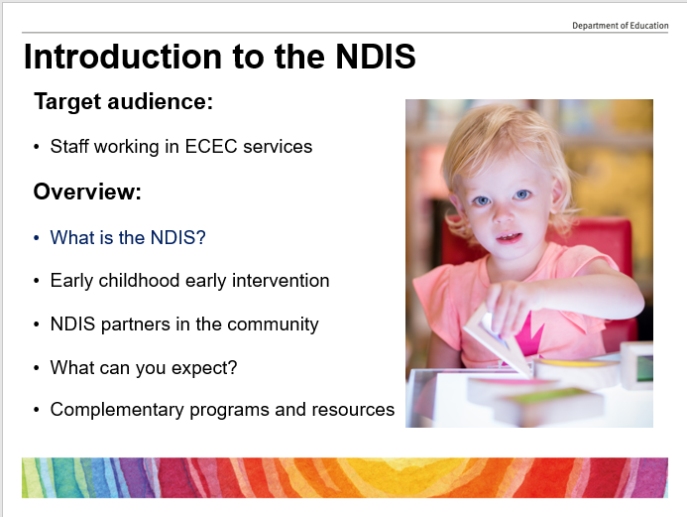 | Introduction to the NDIS | - This webinar will provide a brief overview of the NDIS with a focus on supporting families of children with disability or developmental delay.  - It will cover:  - What is the NDIS?  - Early childhood early intervention  - NDIS partners in the community  - What can you expect? and  - Complementary programs and resources.
3 | 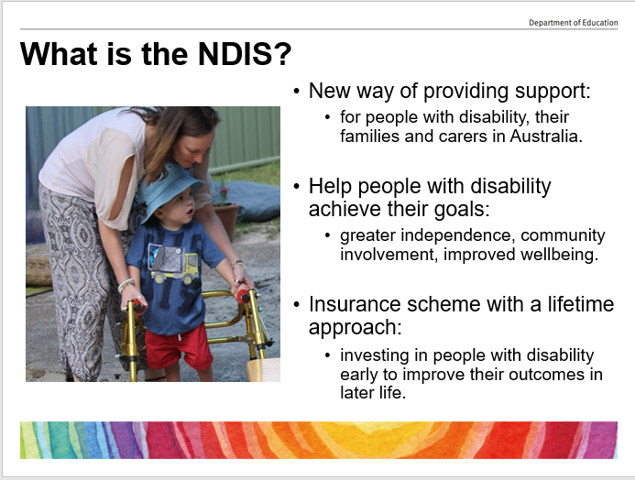 | What is the NDIS? | - The NDIS is the new way of providing support for people with disability, their families and carers across Australia and will help people with disability achieve their goals. This may include greater independence, community involvement, employment and improved wellbeing.  - It is the biggest social reform since Medicare and Australia’s first national scheme for people with disability. It provides funding directly to individuals.  - The scheme will provide supports tailored to the individual through an insurance approach, investing in people with disability early to improve their outcomes in later life.  - The concept of choice and control is central to the scheme, is community focused and needs driven with an emphasis on outcomes.  - It also aims to promote independence, economic and social participation for people with disability.
4 | 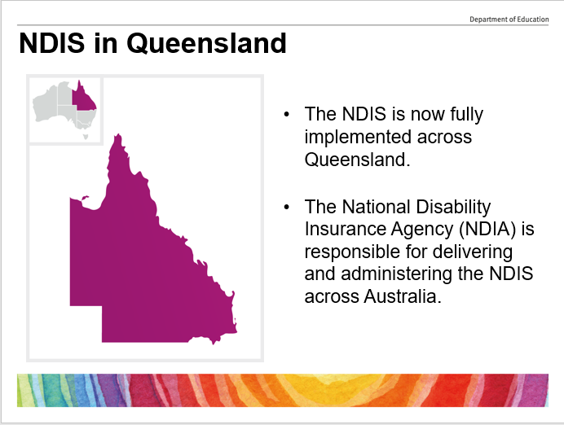 | NDIS in Queensland | - The phased roll out of the NDIS across Queensland is now complete. Queensland’s transition used Local Government Area boundaries and the NDIS community partners (which you will receive further information about shortly) work across these Local Government Areas.  - The National Disability Insurance Agency, a Commonwealth government body (known as the NDIA) is responsible for delivering and administering the NDIS across Australia.  - The NDIA works directly with participants in some areas of Queensland that do not have NDIS community partners and will connect them to the NDIS or to supports in their community.
5 | 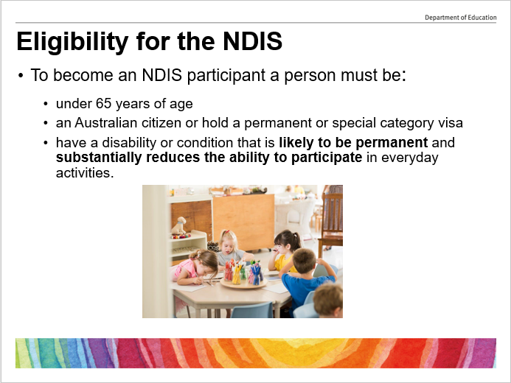 | Eligibility for the NDIS | - For a person to be eligible for the NDIS:  - they must be under 65 years of age at the time of application;  - an Australian citizen, permanent visa holder or Protected Special Category Visa holder; and  - must have a disability or condition that is likely to be permanent and reduces their ability to participate in everyday activities.  - ECEC service staff should not provide advice to families about whether or not a child would be eligible to participate in the NDIS. The NDIS website provides an eligibility checklist with five simple questions to be answered, as a guide to eligibility. The final decision about eligibility is up to the NDIA.
6 | 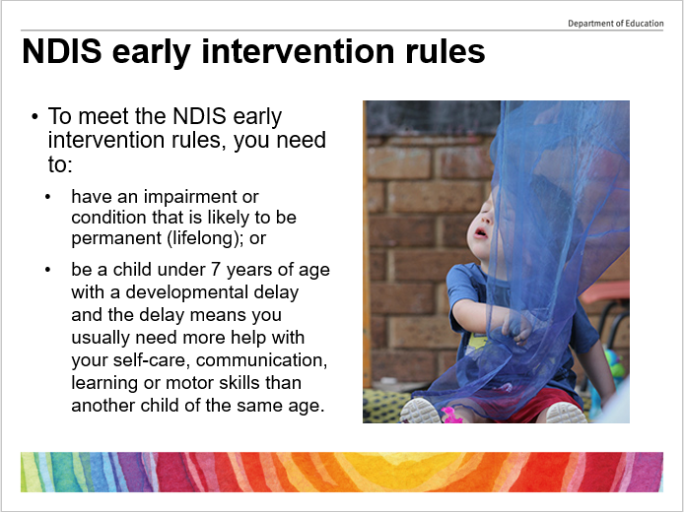 | NDIS early intervention rules | - The NDIS has a set of early intervention rules to guide their operations.  - To meet these NDIS rules, a person needs to:  - have an impairment or condition that is likely to be permanent (lifelong, at any age); or  - be a child under 7 years of age with a developmental delay and the delay means you usually need more help than another child of the same age, with self-care, communication, learning or motor skills.  - Early intervention supports provided by the NDIS are those not provided by any other mainstream services such as health or education.  - Developmental delay is a term used when a child takes longer to reach age-appropriate developmental milestones. For some children developmental delays may be temporary. For others it may be a sign they have another condition, such as Autism. Australian research suggests developmental delay occurs in up to 10 per cent of children aged from birth to 8 years of age.  - It is recommended that staff should not provide advice about whether or not a child would be eligible to participate in the NDIS but direct families to the NDIS website.
7 | 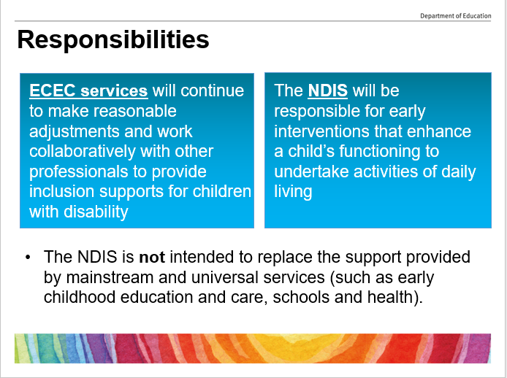 | Responsibilities | - With regard to responsibilities, it is business as usual for ECEC services.  - The NDIS is not intended to replace the supports provided by mainstream services (including schools or early childhood education and care). All ECEC services are required to comply with the Disability Discrimination Act 1992 irrespective of the NDIS eligibility of children with disability and kindergartens are also required to comply with the Disability Standards for Education 2005.  - ECEC services will continue to be responsible for meeting the education and care needs of children with a development delay or disability, including through:  - reasonable adjustments;  - inclusion supports that enable children to participate in early childhood education and care settings; and  - building the capacity of early childhood education and care services to provide inclusive education and care to all children, including those with high needs subject to reasonable adjustment.  - The NDIS will be responsible for personalised individualised supports required due to the impact of the child’s impairment on their functional capacity and additional to the needs of children of a similar age and beyond the reasonable adjustment requirements of early childhood service providers.  - They will work with and through a child’s family, carers and educators to implement supports or early interventions that promote and support the functional capacity of the child.  - In summary, the NDIS will be responsible for early interventions for children with disability (or development delay) which are:  - specifically targeted at enhancing a child’s functioning to undertake activities of daily living or specialised supports to transition a child with disability into school (not supports, such as school readiness programs, which are for the purpose of accessing universal education);  - likely to reduce the child’s future support needs which would otherwise require support from the NDIS in later years, including through a combination and sequence of supports (not including medical and health treatments outlined in the health interface); and  - supporting connections and access to community and mainstream services.
8 | 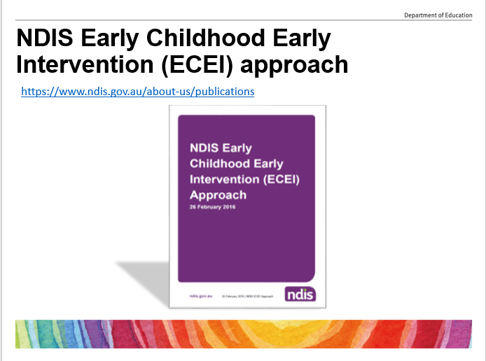 | NDIS Early Childhood Early Intervention (ECEI) approach | - The NDIA released its Early Childhood Early Intervention approach (known as the ECEI approach) back in February 2016 for children with developmental delay or disability from birth to six years of age. The approach was developed with input from leading early childhood intervention researchers and practitioners to provide nationally consistent, best practice early intervention support to children and their families.  - It is based on research which shows that inclusion and participation in everyday environments and activities provides children with opportunities for developmental growth and social participation.  - The NDIA has sourced experienced early childhood intervention service providers to work as its Early Childhood Early Intervention community partners (ECEI or early childhood partners as they are sometimes referred to) to ensure the NDIS supports all children as early as possible. The ECEI partners have strong clinical expertise and utilise best-practice approaches. The NDIA closely monitors disability service provider performance and outcomes to ensure all children receive the appropriate quality and level of support.  - As an insurance scheme, the NDIS also uses effective early intervention to reduce its medium to long-term liability.
9 | 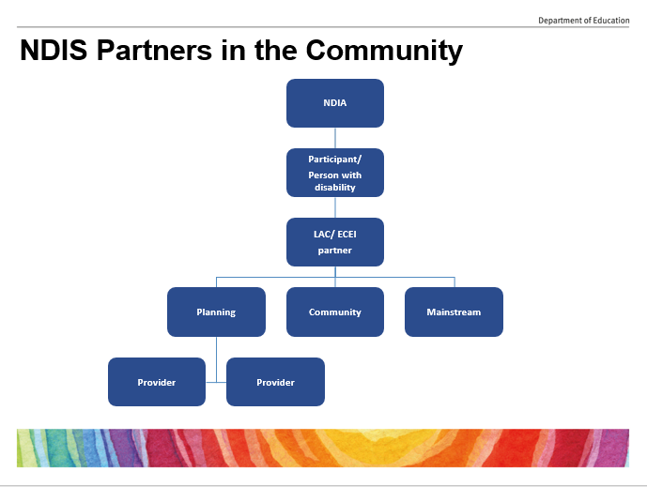 | NDIS Partners in the Community | - The NDIA established its presence across Queensland along with both Local Area Coordination Partners (known as LAC partners) and Early Childhood Early Intervention Partners (known as ECEI partners).  - The role of these NDIS partners is to help people understand the NDIS, access the NDIS and create a first plan, provide connections into the community, undertake planning and identify responsibilities of mainstream services. For most people these partners will be the main contact point for the NDIS.  - The LAC partner role for people with disability over seven years and under 65 years of age includes helping you to understand the NDIS, information gathering for creating initial plans, plan implementation, review of plans and community capacity building.  - The ECEI partner role for children aged birth to six years of age with disability or developmental delay includes:  - information gathering;  - community connections (for example with the community health centre, educational setting or playgroup);  - initial supports and responses; and  - access recommendations if your child requires longer-term supports, plan development linked to early intervention outcomes and plan review.  - As every child is different, your ECEI Partner will tailor support to your child’s individual needs and circumstances and will provide you with information.  - Mainstream services include Community Child Health, Queensland Health, Department of Education (as in schools), Early Childhood Education and Care services, transport services, etc.  - Providers are critical to the success of the NDIS. The NDIS need a strong and vibrant disability service provider market that contributes to improving outcomes for participants.
10 | 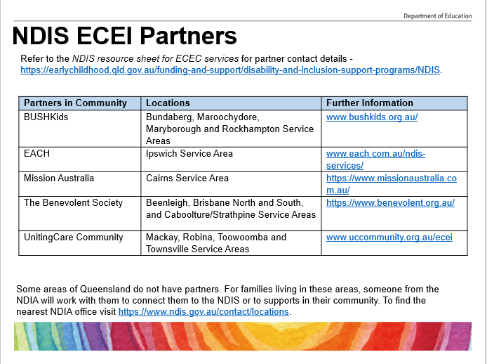 | NDIS ECEI Partners | - ECEI partners for each of the NDIS Service Areas are listed on the slide.  - For partner contact details, refer to the NDIS resource sheet for ECEC services (the url for this resource sheet is at the top of the slide).  - Some areas of Queensland do not have NDIS partners. For families living in these areas, the NDIA will work with them to connect them to the NDIS or to supports in their community.  - To find the nearest NDIA office, visit the NDIS contact page (the url for this page is at the bottom of the slide).
11 | 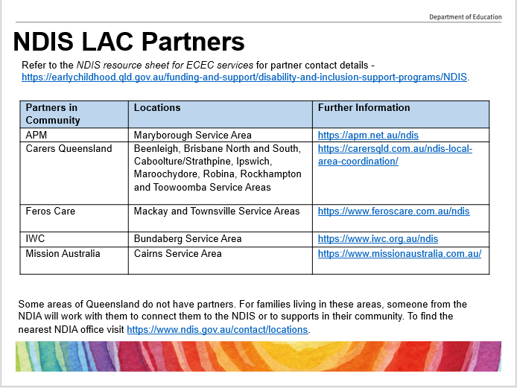 | NDIS LAC Partners | - LAC partners for each of the NDIS Service Areas are listed on this slide.  - For partner contact details, refer to the NDIS resource sheet for ECEC services (the url for this resource sheet is at the top of the slide).  - Similarly, some areas of Queensland do not have NDIS partners. For families living in these areas, the NDIA will work with them to connect them to the NDIS or to supports in their community.  - To find the nearest NDIA office visit the NDIS contact page (the url for this page is at the bottom of the slide).
12 | 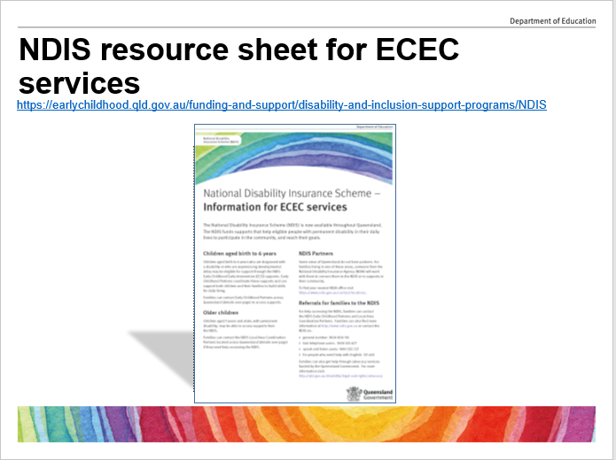 | NDIS resource sheet for ECEC services | - The NDIS resource sheet for ECEC services provides a snapshot of information to assist ECEC services staff in referring families to the NDIS and their community partners.  - It is available on the ECEC NDIS web page (the url for this page is at the top of the slide).
13 | 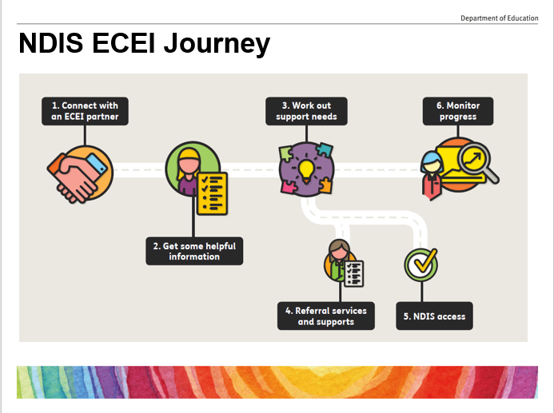 | NDIS ECEI Journey | - Initially, families will meet with an NDIS ECEI partner to discuss their needs. The access partner will draw on their specialised early childhood knowledge to determine appropriate supports for the child and family, including information, emotional support and specialised early intervention supports.  - With an emphasis on inclusion, each child will be supported in a range of mainstream settings, such as kindergarten, playgroup and other early childhood settings. This gives them an increased opportunity to learn and develop positive social relationships.  - Supports will be delivered through a family-centred approach, which builds on family and carer strengths in order to improve the child’s developmental trajectory and overall quality of life.  - ECEI partners provide support and services to children and their families (not directly to ECEC services).  - A child who requires more intensive early intervention support services will get a plan of supports and each family will be able to choose providers to best meet their child’s needs.  - What does this look like? Therapy services, behaviour support, assistive technology, supports for parents, etc.
14 | 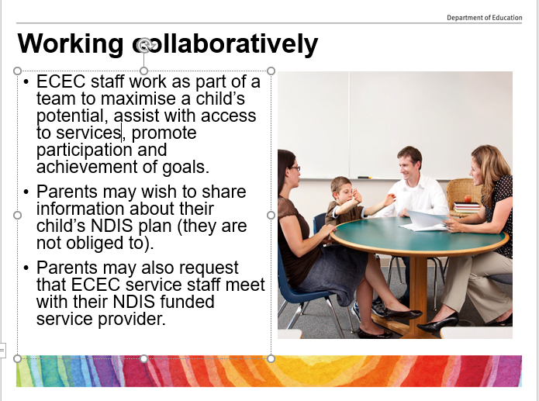 | Working collaboratively | - Parents may wish to share information about their child’s NDIS plan.  - They may also request that ECEC services staff meet with their NDIS funded service provider to share information and support a collaborative approach across the child’s natural learning environments, including home and early childhood education and care.  - Some parents and their transdisciplinary teams may request to work with the ECEC educators and support workers to ensure a consistent approach for the child.  - It is intended that the NDIS and the systems providing early childhood supports will work closely together at the local level to plan and coordinate streamlined services for individuals requiring both disability services and early childhood supports, recognising that both inputs may be required at the same time or that there is a need to ensure a smooth transition from one to the other.  - The transdisciplinary approach (that is working collaboratively with other professionals) places the family at the centre of all services and supports:  - The child is included in the home and community life, with additional supports as needed.  - The child learns and practices skills through participation in the activities and routines of daily life.  - A team supports the family – communicating and sharing information, knowledge and skills, with one main person known as the key worker.  - The key worker may work with speech language pathologists, occupational therapists, physio therapists, early childhood intervention educators, psychologists, behavioural specialists or social workers who come in and out the team as required.  - It should be noted that the NDIS does not provide funding for ECEC services or ECEC fees.
15 | 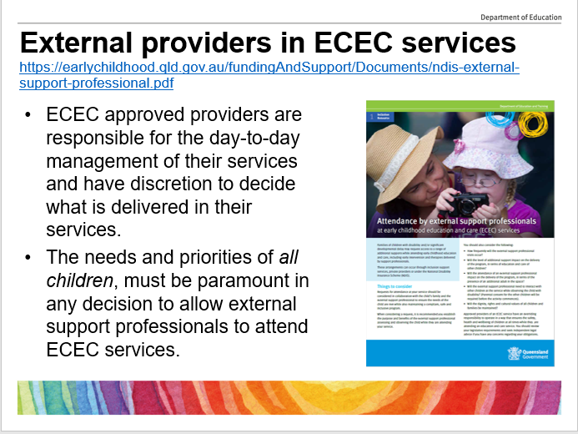 | External providers in ECEC services | - ECEC approved providers are responsible for the day to day management of their services. They need to interact with families and they have the discretion to decide what is delivered in their service.  - The needs and priorities of all children, must be paramount in any decision to allow external support professionals to attend services.  - The Early Childhood and Community Engagement Division has developed a resource sheet titled ‘Attendance by external support professionals at ECEC services’. This resource provides a list of considerations before allowing access to external providers including:  - frequency of the visits by the external support provider;  - impact on delivery of the program – eg supervision of all children;  - presence of an additional adult in their service – parental consent required;  - Blue card requirements; and  - information sharing.  - Considerations of requests for access may result in varying responses from the approved provider based on the request, for example:  - a one off request from a disability provider wishing to observe a child interacting with peers at play in their natural environment; as opposed to  - a request for weekly visits for a disability provider to use the Director’s office to conduct individual speech therapy sessions.  - This resource sheet is available on the department’s ECEC NDIS web page (url on the top of the slide).
16 | 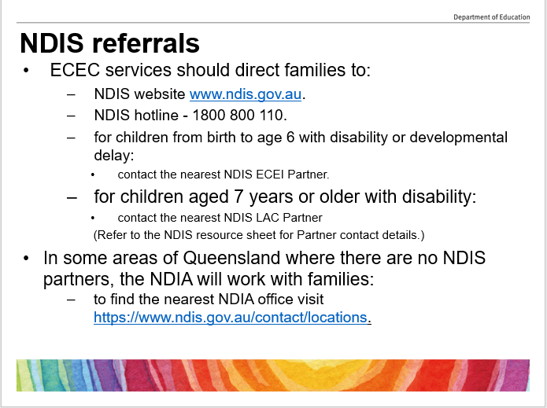 | NDIS referrals | - ECEC services staff are not expected to provide families with specific information about the NDIS.  - Instead they should refer families directly to the NDIA, NDIS ECEI Partners (for children from birth to age six) or NDIS LAC Partners (for children aged 7 years or over).  - These agencies can assist families needing support for their child and are able to assist families with the completion of any necessary NDIS paperwork.  - Contact details for the NDIA and NDIS partners are available on the NDIS resource sheet available from the ECEC NDIS web page (the url for this page is on the previous slide).
17 | 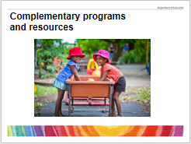 | Complementary programs and resources | - The following programs and resources have been specifically designed for the early childhood sector to support children with disability or developmental delay and their families.
18 | 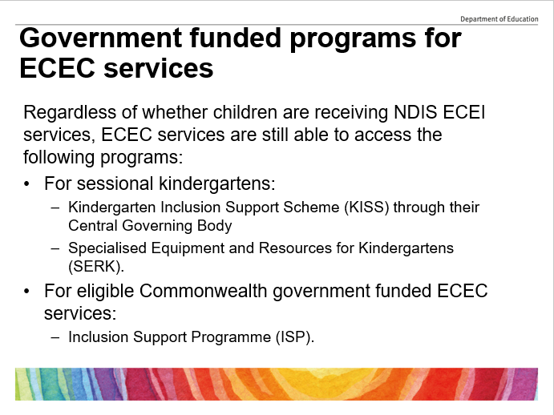 | Government funded programs for ECEC services | - NDIS related services, packages or funding are for a child with disability or developmental delay and the money is allocated to the family for the child.  - The state government provides two support programs for sessional kindergartens to access:  - the Kindergarten Inclusion Support Scheme ( known as KISS) accessible through their Central Governing Body; and the  - Specialised Equipment and Resources for Kindergartens program (known as SERK).  - The commonwealth government also provides support for eligible services such as Long Day Care, Outside School Hours Care and Family Day Care through the Inclusion Support Programme.  - Regardless of whether children are receiving any type of NDIS supports, ECEC services are still able to access these state and commonwealth government funded programs where support and funding is allocated directly to ECEC services.
19 | 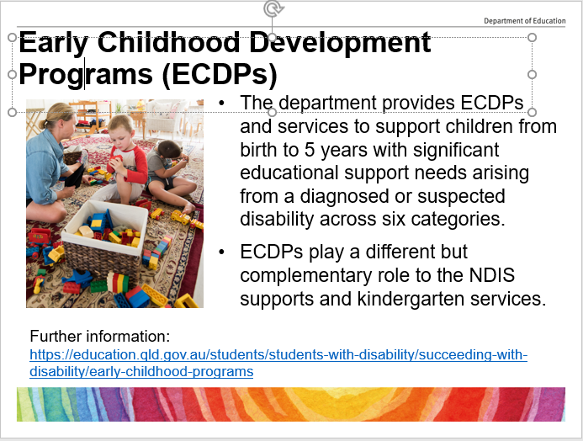 | Early Childhood Development Programs (ECDPs) | - Under the NDIS Act 2013, early intervention services are identified as the responsibility of the NDIS, while the federal and state governments will continue to fund early childhood education and care.  - The Queensland government through the Department of Education provides Early Childhood DevelopmentPprograms (ECDPs) and services to support children aged birth to five years with significant educational support needs arising from a diagnosed or suspected disability in the categories of autism spectrum disorder (ASD), hearing impairment, intellectual disability, physical impairment, speech-language impairment and vision impairment.  - Education regions coordinate the delivery of ECDPs and services to provide early intervention to children who require intensive, multidisciplinary programs to develop skills and behaviours to maximise their participation in schooling.  - Where agreed, the ECDP or service, early intervention provider and/or kindergarten staff will work together with the child's future school to assist the child and their family to make a smooth transition to Prep.
20 | 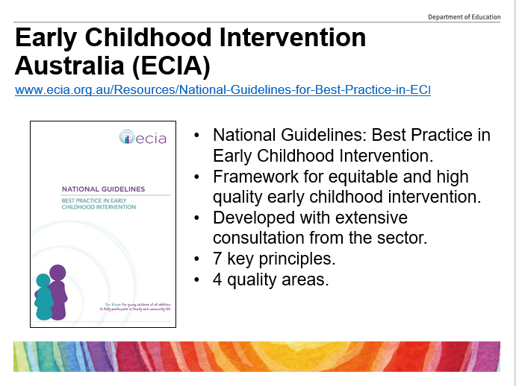 | Early Childhood Intervention  Australia (ECIA) | - In 2016 Early Childhood Intervention Australia (known as the ECIA) published the National guidelines: Best practice in early childhood intervention for the early childhood sector.  - The purpose of these guidelines and the recommendations is to provide a framework for universal and equitable high quality early childhood intervention based on best practice for children with disability and/or developmental delay whether they attend government, non-government, large, small, sole not-for-profit service providers or private providers, anywhere in Australia.  - These guidelines and recommendations draw upon extensive consultation with early childhood intervention specialists and key stakeholders.  - ECIA considers early childhood intervention as supporting a child’s development of functional skills that would enable them to participate meaningfully in everyday activities alongside developing peers.  - The early intervention seven key principles: Looks Like/Doesn’t Look Like presents best practice principles in plain language and details their application for infants and toddlers in early childhood intervention settings.  - At the core of the guidelines are four quality areas: family, inclusion, teamwork and universal principles.  - Early childhood intervention supports need to be provided in a way which is inclusive of the family so that activities are targeted to encourage the learning and development of the child and are reinforced and complemented in family settings.  - It should be noted that the term “natural environment” includes ECEC settings
21 | 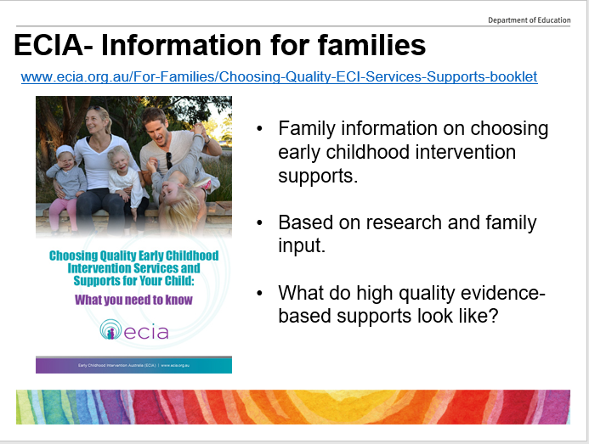 | ECIA- Information for families | - Early childhood intervention services have changed over the years. These changes have been based on research evidence and family input. This means that sometimes services may look different to what families might expect.  - ECEC services may like to refer families to this easy to read booklet produced by ECIA providing family information on choosing early childhood supports and services.  - This booklet provides information on what high quality evidence-based services and supports look like, to assist families in choosing the right supports and services that will ensure the best possible outcomes for their child and family.
22 | 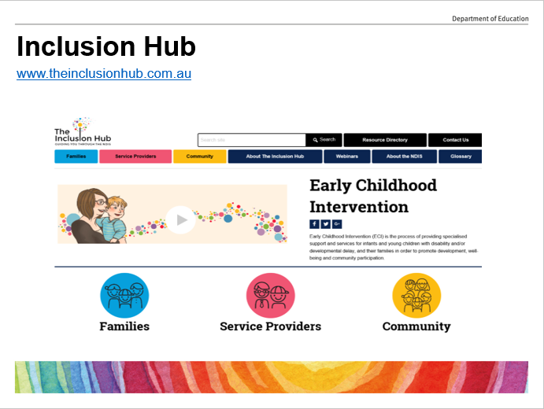 | Inclusion Hub | - The Inclusion Hub is an online tool developed to support Australian families, communities and practitioners with the resources they need to take control of their journey with the NDIS.  - The website incudes overviews and articles, a glossary, newsletters, website links, checklists, a resources directory and more.
23 | 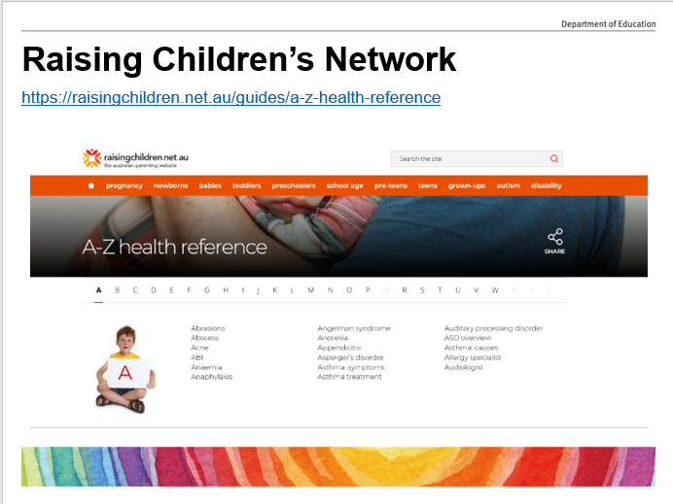 | Raising Children’s Network | - The Raising Children's Network site provides information in relation to disabilities, medical conditions and information on assessment and diagnosis of a child.  - ECEC services staff may find this site useful to understand some of the disability types that children may present with.  - A range of video clips on Disability diagnosis: parent stories and expert overviews are also available.
24 | 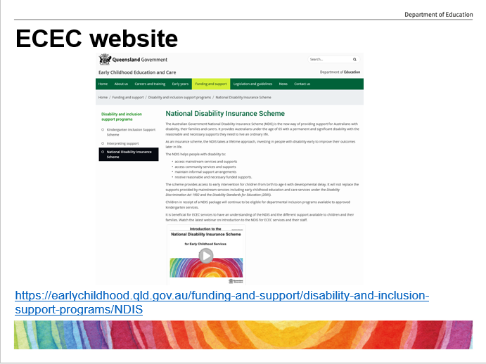 | ECEC website | - The department’s ECEC website includes a number of pages related to supporting children with disability and developmental delay. These include:  - service obligations;  - funding and support programs;  - NDIS, including early intervention;  - professional development resources – Early Years Connect with 15 information sheets, 8 online modules and 16 webinar recordings; and  - NDIS and disability resources including links to helpful sites with video clips, information booklets, recorded webinars and valuable information for both educators and parents.
25 | 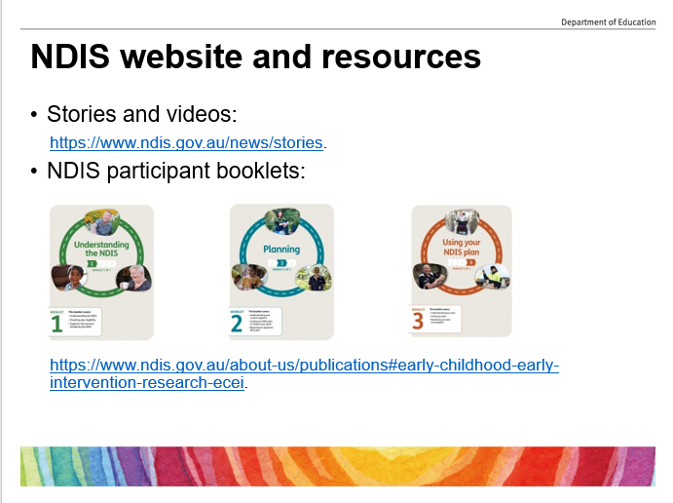 | NDIS website and resources | - The NDIS website has many print and video clip resources available to help families get ready for their NDIS journey.  - ECEC services staff may like to refer families to access these resources and the three NDIS participant booklets:  - Understanding the NDIS;  - Planning; and  - Using your NDIS plan.
26 | 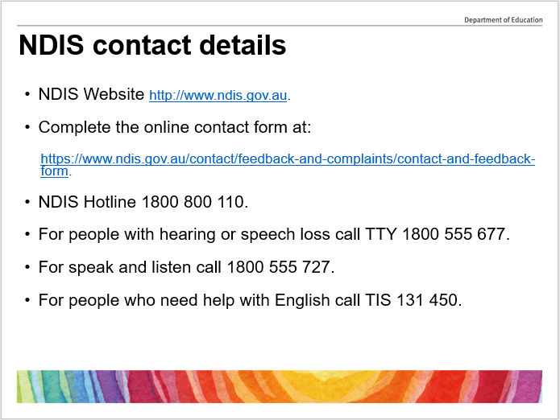 | NDIS contact details | - ECEC services staff may like to refer families to the NDIA for further information. Contact details are available on this slide.  Thank you for listening.

